Ahmad, I met with Jireh this morning and we outlined some major framework updates we will need.
- Excel back up for both budget and RFP should match: margin analysis and LED sheet should be present in both.
- Budget sheet currently has project summary info page we would want to see in the RFP Excel as well with name, date etc etc.
- Very important that everything in the excel is formulas with link between pages, for instance when I update number of screens on LED sheet, it increases cost which is shown increased on the Margin analysis. Any manipulations with install number are linked to margin analysis so they translate there.

We should also have an opportunity to mess with numbers online in the engine and to have everything updated throughout.

- Margin analysis and LED sheet should be recognized by the mirror mode so instant PDF can be generated; from both RFP and Budget builder. Goes without saying that every project we price will be presented to the client; so just confirming this point.
These are major things.
Minor comments:
- LED sheet preview online has weights electrical info etc but exported version still does not ) flagged by Jireh yesterday)- we just tried this am and still does not show
- Margin analysis that is currently in RFP builder (and we want to adopt throughout) is a good start , couple minor changes:
  - move cost selling price margin etc at the bottom of each option
  - roll spare part cost into LED hardware, no need to be separate line
  - the rest group together under Processor and equipment; add back up sheet where we can change those and call it Bundle equipment.
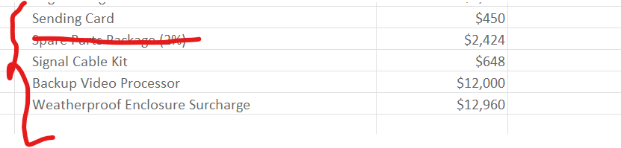
  - each screen should have subtotal; tax, bond-grand total – think how our current Margin analysis is layed out. – that way we can have base and alt. Otherwise, it will get messy to calculate base bid grand total.

- Lets add one sheet that is a replica of LED cost sheet with all the technical specs no pricing to share with installers subs. – can be very last one. That way Jeremy/Matt can just extract and fire away.

